**Brooklyn torah gazette**

**For parshas vayetzei 5783**

Volume 7, Issue 11 (Whole Number 318) 9 Kislev 5783/ December 3, 2022

**Printed L’illuy nishmas Nechama bas R’ Noach, a”h**

For a free subscription, please forward your request to [***keren18@juno.com***](mailto:keren18@juno.com)

Past stories can be found on the website **ShabbosStories.com**

**Important Halachas Regarding The Recitation of Tehillim**

**By Daniel Keren**

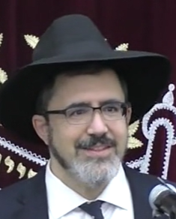

**Rabbi Shai Tahan**

The second speaker at the recent 2022 Hakhel Flatbush Veterans Day Yarchei Kallah Event at the Agudath Israel of Madison was Rabbi Shai Tahan, author of the sefer “Shaf V’Ysiv on Hilchos Tehillim” and Rosh Kollel of Shaarei Ezra, Benei Yosef who spoke on the topic of Halachot (laws) of Tehillim (the recitation of Psalms.)

Rabbi Tahan began by warning the audience at the Hakhel Yarchei Kallah Event that one has to be especially careful when reading or reciting Tehillim and also with Tefillah (prayers). For example, if when reciting Tehillim or praying, one has an excess of saliva, if one spits out that saliva when one has just said Hashem’s name, this is a terrible aveira (sin) and can cause serious spiritual punishments to the individual.

Another question that Rabbi Tahan raised is whether it is permissible to eat and drink in the middle of reading a perek (chapter) of Tehillim. The Mishna Berurah authored by the Chofetz Chaim, Rabbi Yisroel Meir Kagan, 1838-1933 makes a distinction, declaring that with regards to the certain chapters of Tehillim/Psalms that are recited in the morning on Rosh Chodesh (the New Month) and Yomim Tovim (festivals), one is not allowed to interrupt by either talking or eating/drinking.

The Mishna Berura would allow interruptions with regards to the general reading of Tehillim. Hacham Ovadia Yosef, 1920-2013 the Rishon LeZion (Chief Sephardic Rabbi of Israel) wrote that one could be lenient with regards to whether a person could drink coffee during the first part of Shachris (the morning service) where one recites chapters of Tehillim.

**When Can One Sings Songs from Verses of Psalms?**

Are songs composed from pasukim (verses) of Tehillim (Psalms) permitted? Rabbi Tahan noted that more recent poskim (rabbis who answer halachic/legal questions) hold that it is indeed permissible to create songs from verses of Psalms if it is done in a respectful manner, especially if these songs will help elevate the listener’s ruchnius (spiritual sensitivities).

Another question addressed by Rabbi Tahan was whether or not it is permissible to read Tehillim in English or other secular languages or must one only recite Tehillim in lashon hakodesh (the holy language – Biblical Hebrew)? What if by being forced to read Tehillim in lashon hakodesh, this will result in the individual not understanding the meaning of the pesukim that he is reciting?

The Rif (Rabbi Yitzchak Alfasi, 1013-1103) is of the opinion that with regards to Tefilah (prayers) if one is davening with a minyan or tzibbur, one can pray in whatever language he is comfortable with. If, however, he is praying alone, the Rif says that he should read the Tefillah prayers in lashon hakodesh and similarly if one is reciting Tehillim by himself, he should only read it in lashon hakodesh.

Rabbi Tahan also quoted the Kaf Hachaim (Rabbi Yaakov Chaim Sofer, 1870-1939) who argues that although the Rif permits reading Tehillim [in certain situations] in other languages, there are nevertheless important special spiritual powers from the very holy words of Tehillim that are lost when read in translation. Therefore, the Kaf Hachaim recommends strongly reciting Tehillim in its original lashon hakodesh.

**The Dangers of Translations of Tehillim**

Rabbi Tahan said that the dangers with translations is that the words chosen by the translator may not be in accord with the understanding and the teachings of Chazal, our Sages of blessed memory (from the time of the Gemora or Talmud) who were blessed by Hashem with a special ruach hakodesh.

A final question that Rabbi Tahan addressed in his Veterans Day Hakhel Yarchei Kallah shiur was regarding the controversy about reading Tehillim for the sick. Can one recite Tehillim for the intent that it should cause a healing for the choleh (sick individual?)

Basically, it is forbidden to rely solely on the recitation of Tehillim for a healing. But if the reading of Psalms is in conjunction with others forms of healing (i.e., medical treatments) than it would be permitted.

Reprinted from an excerpt of the November 24, 2022 edition of the FJJ (Flatbush Jewish Journal).

**Thoughts that Count**

**For Our Parsha**

**And Laban said, "It is better that I give her to you, than that I should give her to another man."** (Gen. 29:19)

Laban was very eager for his daughter to marry Jacob. He knew that both Jacob and his daughter Rachel were righteous. If they were to marry other people, then surely Jacob would influence his wife to become righteous and Rachel would do the same for her husband. If that happened then Laban, a wicked person, would have to contend with four righteous people! But if Jacob and Rachel married each other, he'd only have to deal with the two of them. *(Reb Bunim M'Pshischa)*

**And Laban called it "Yagar Sehaduta," but Jacob called it "Galeed." And Laban said, "This heap of stones is a witness between me and you this day." Therefore, he called it Galeed.** (Gen. 31:47-48)

Laban called the place by one name, and then automatically changed his mind and gave it the name that Jacob chose. Laban was eager to make peace with Jacob, but he wanted it to be done in his own language. Jacob told Laban that if he wanted peace it would have to be on his terms and in his language. When Laban saw that Jacob refused to back down, he agreed to his terms. *(Sforno)*

*Reprinted from the Parshat Vayeitzei 5758/1998 edition of L’Chaim. Adapted from Vedibarta Bam - By Rabbi Moshe Bogomilsky*

**Rav Avigdor Miller on**

**Big Small Achievements**

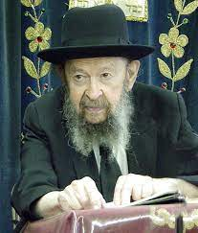

**QUESTION: What should a person do if he wants to become great but he realizes that he lacks the motivation to accomplish it to the fullest extent that he desires?**

**ANSWER::** Look.  Here’s a man who would like to become a millionaire.  He’s walking in the street and he sees a measly twenty dollar bill lying in the gutter. Now, twenty dollars won’t make him a millionaire but will he pass by?  No. Even a millionaire will stoop down and pick it up.

And the answer is, every little bit is valuable.  If you’re able to control your character at least one little bit, a little tikkun, that’s already valuable. If you keep quiet a little bit – if instead of talking a thousand words a day, you’ll talk 999 words, it’s already a big achievement.

And therefore, it’s only because people don’t realize how great is the achievement in ruchniyus, they don’t realize that when it comes to the spiritual achievements of improving your character even the smallest amount is worth doing, that’s why people don’t grab the opportunities.

And therefore, nobody should disdain that; just because he cannot become a tzaddik like Moshe Rabbeinu doesn’t mean he shouldn’t bend over and pick up the twenty-dollar bill anyhow.

*Reprinted from the August 23, 2022 email of Toras Avigdor (Tape #E1 – February 1999).*

**The Jew’s Responsibility to Bring G-dliness to Even the Lowest Places on Earth**

**From the Talks of the Lubavitcher Rebbe**

**Rabbi Menachem Mendel Schneerson, Zt”l**

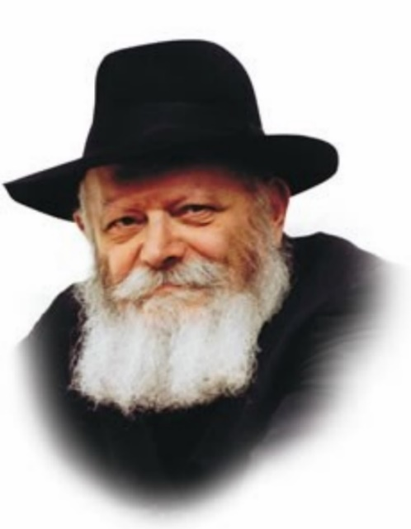

In this week's Torah portion, Vayeitzei, we read about Jacob's departure from the Land of Israel for Charan and his subsequent dealings with Laban.

The first thing the Torah tells us is that "he reached a certain place," i.e., Jacob prayed. We then learn that Jacob worked for Laban for 20 years, married, and fathered the Twelve Tribes. Then, on his way back to Israel, Jacob was met by "angels of G-d."

**Not a Book of Stories**

The Torah is not a book of stories, G-d forbid. The word Torah is derived from hora'a, Hebrew for teaching, as the events that the Torah relates are a guide for us to apply in our daily lives.

Just as Jacob left the sanctity of the Land of Israel and his Torah studies to go to Charan at G-d's command, so too is every Jew enjoined to go out into the world and involve himself with "Laban the Aramaean."

**A Time to Leave “the Land of Israel”**

A Jew must never isolate himself within the "four cubits of Torah study," but must leave "the Land of Israel" -- his preoccupation with G-dliness and holiness -- to travel to even the lowest places on earth in order to draw his fellow Jews closer to G-d and to mitzvot. And, like Jacob, the Jew must always conduct himself like a tzadik (righteous person), even in "Charan," the most trying and difficult of circumstances.

The first thing Jacob did upon leaving the Holy Land was "vayifga bamakom -- and he reached a certain place." Jacob actively sought out Hamakom (referring to G-d), and was indeed rewarded with a revelation of G-dliness that came to him in a dream.

**No Need to Seek G-d at Certain Times**

Years later, however, when Jacob left Charan to return to Israel, there was no need for him to seek G-d out, for "he was met there by angels of G-d." After 20 years of G-dly service in Charan Jacob did not have to initiate the search; the angels and G-d Himself came to him! Indeed, Jacob merited an even higher revelation of G-dliness, one that occurred while he was awake and not while dreaming.

When a Jew goes out toward "Charan," spreading Judaism and drawing his fellow Jews nearer to G-d, his departure from the rarefied world of G-dliness and holiness is not a descent, but in actuality, constitutes a very great ascent. In Charan, Jacob merited both physical and spiritual success, as it states, "And the man increased exceedingly."

**The Power of the Service in “Charan”**

When a Jew is "in the Land of Israel" -- involved in his own spiritual perfection to the exclusion of others, no matter how great his achievements he can never attain the level that is reached through the service in "Charan." For it is only when he goes out into the world to draw his fellow Jews closer to G-d that he merits a much higher degree of both material and spiritual success.

*Reprinted from the Parshat Vayeitzei 5758/1998 edition of L’Chaim. Adapted from Likutei Sichot, Volume 3.*

**Rabbi Berel Wein on**

**Parshas Vayeitzei 5783**

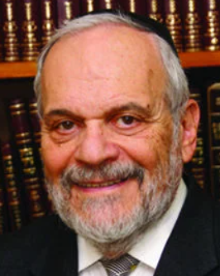

Our father Jacob was a very strong and powerfully physical person. We read of his physical prowess in his previous encounter with the shepherds of Haran and later of his wrestling match with the angel of Esav, at the river of Yaabok. His sons, though young in years, are also very powerful and strong physically and filled with self-confidence, without fear of confronting dangerous enemies.

We will see that his two sons, Shimon and Levi, destroy the city of Shechem in their rage and sense of justified revenge for the behavior against their sister Dena. And according to Jewish legend, as quoted by Ramban in his commentary, Jacob engaged in many battles against hostile tribes after entering the Land of Israel.

And yet the overall picture of our father Jacob that emerges from the narrative recorded in the Torah is one of appeasement and an avoidance of confrontation at almost all costs. He allows both Lavan and Esav to threaten him and, in effect, he chooses to buy them off with words and gifts.

There is little evidence of the true strength and power of Jacob in the Torah narrative itself. It is obvious that that there is a dual nature present in the portrait that the Torah describes regarding our father Jacob. And there is a profound lesson present in that purposeful presentation that the Torah has made for us to learn and follow.

We are all aware that the narrative regarding the lives and experiences of our patriarchs and matriarchs is meant to be instructive, as are all the events in Jewish history. During first and second Temple times, when the Jewish people had national sovereignty, they engaged in many wars and battles and were well known throughout the area as a fierce foe. As a matter of fact, Josephus records that the wars of the Jews were the most fearsome in the history of the Roman Legions.

However, after the destruction of the second Temple and the rise of Christianity and later Islam, the Jews became a persecuted minority and almost powerless in terms of physical strength. The entire history of the exile is how the Jewish people lived by their wits, with low profiles and with appeasement of their enemies. Since the exile has lasted for such a long time, this attitude and self-assessment became ingrained in the Jewish psyche. It is only when the nadir of the Jewish exile was reached through the Holocaust that the situation of Jewish self-assessment and self- assertion began to change.

The creation of the State of Israel is undoubtedly the catalyst for this change. The success of the Jewish State, far beyond even the wildest hopes of previous generations, has emboldened Jewish life throughout the world. It has enabled Jews to become publicly Jewish and observant even while holding high office in non-Jewish societies and countries. It is the time of the children of Jacob reasserting themselves in pride and strength. May it continue to embed itself in the brains and hearts of Jews.

Shabbat Shalom

*Reprinted from this week’s website of rabbiwein.com*

**How to Connect to G-d**

Behold, the L-rd was standing over him ("Vehinei Hashem nitzav alav") (28:13) Rearranging the first letters of the above Hebrew verse results in the word "anav," meaning one who is humble. For it is precisely through humility, self-abnegation and acceptance of the yoke of Heaven that a person attains a sense of G-d's closeness. (Ohr HaTorah)

*Reprinted from this week’s email of R’ Yedidye Hirtenfeld’s whY I Matter parsha sheet for the Young Israel of Midwood in Brooklyn, NY.*

**Rabbi Yitzchak Tuvia Weiss, Zt”l**

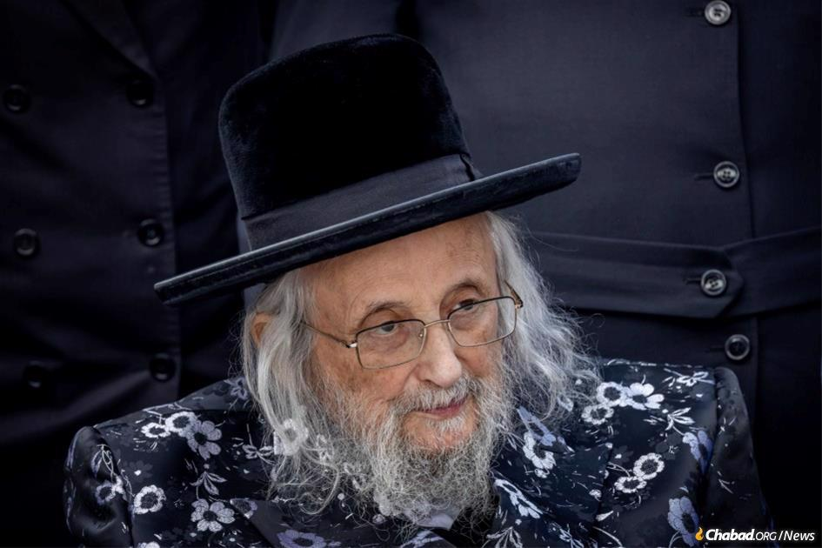

Rabbi Yitzchak Tuvia Weiss, Zt”l (26 August 1926 – 29 July 2022) was born in the town of Pezinok near Bratislava in Czechoslovakia. His father, Rabbi Shlomo, was a Magid Shiur and disciple of the Shevet Sofer.

Since there were not enough children in the town to maintain a Talmud Torah, Yitzchak attended the state school and studied Torah with a private teacher. In 1939, 12-year-old Yitzchak was sent on a kindertransport organized by (mechasidei umois haolam) Mr. Nicholas Winton, a British Jew who succeeded singlehandedly in rescuing 669 children just weeks before World War II broke out.

Most of Rabbi Weiss’s family remained behind and perished in the Holocaust. Rabbi Weiss tried to meet with Winton after the story of his rescue became known in the last few years but Winton passed away before he could meet him.

In a letter he wrote to Winton’s family, he said that “he had succeeded in saving my life as well as a large number of other people. His noble memory, courage and devotion will be with us forever and can serve as a consolation to you.”

Rabbi Weiss was taken to the house of the Sassover Rebbe in London, who hosted him together with other children from the kindertransport. In London he studied at Rabbi Moshe Shneider’s yeshiva together with Yibadel Lechaim Rabbi Moshe Sternbuch shlita, who is the posek of the Eda Chareidis.

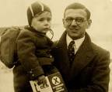

**Mr. Nicholas Winton with one of**

**the 699 Jewish children that he**

**saved before World War II broke out**

Later he studied in Gateshead and after his marriage continued his studies in Gateshead Kollel under Rabbi Eliyahu Dessler. When Rabbi Dessler left to become Mashgiach in Ponovezh, Rabbi Weiss served as head of the Kolel in his place, receiving his semicha from Rabbi Shakovitzky and Rabbi Rabinoff zts’l.

Rabbi Weiss moved to London where he taught in Yeshivas Haramah of Rabbi Elyakim Schlesinger and later become the rabbi of the Etz Chaim shul in London. During this period, he was close to the Shatzer Rebbe, Rabbi Sholom of Shatz.

In 1967 Rabbi Weiss moved to Belgium, where he lived for 37 years. He served as a rebbe at the Etz Chaim yeshiva there and later became a dayan for the local community. He also held a position as rav of the Gerer Beis Midrash and the Avreichim Beis Midrash.

Rabbi Weiss had warm ties with many of the gedolim, including the rebbes of Gur and Satmar and the Skulener and Pshevorsk rebbes. He also maintained ties with the Steipler and wrote many letters to him and had a warm relationship with Rabbi Chaim Kanievski. Rabbi Weiss would often visit Rabbi Chaim in Bnei Brak and a few years ago Rabbi Chaim made a visit to Rabbi Weiss as well and spoke with him in learning. Rabbi Weiss also maintained a relationship with Rabbi Meir Zvi Bergman, son-in-law of Rabbi Shach, and Rabbi Shmuel Auerbach, whom he collaborated with on various issues.

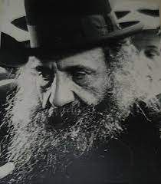

**Rav Moshe Schneider, zt:l**

After the passing of Rabbi Yisrael Moshe Dushinsky in 2003, Rabbi Weiss was called to serve as Gaabad (leader) of the Eda Charedis in Jerusalem. Initially he lived near the Dushinsky shul in Arzei Habirah but later settled in the Givat Moshe neighborhood.

**Helped Needy Families and Assisted Parents in Marrying Off Children**

During his tenure at the Eda Charedis, he established the Peer Hatorah yeshiva for youths from the community, later changing the name to Chochmas Hatorah. He served as a rosh yeshiva, giving shiur klali and other monthly shiurim. He also established a special tzedaka fund for needy families and would give special support to parents marrying off children including covering the costs of the wedding night.

**Wrote Sefer on Sugyos in Shas**

Rabbi Weiss wrote Shaarei Tuvia on sugyos in shas. A number of books have been published by disciples including his halachic rulings and other stories from his life. Rabbi Weiss was predeceased by his third wife (his children were born from the first wife, Esther Fleischman) and one son-in-law, Rabbi Avraham Zilbiger of Manchester.

**Survived by Son and Son-in-Law**

He is survived by his only son Rabbi Shlomo Zalman as well as his son-in-laws Rabbi Elimelech Zilbiger – a leader of Breslav chasidim in Beit Shemesh and Rabbi Shlomo Meir Lindbaum, as well as grandchildren and great-grandchildren. Yehi Zichro Boruch (VINeies)

*Reprinted from this week’s email of R’ Yedidye Hirtenfeld’s whY I Matter parsha sheet for the Young Israel of Midwood in Brooklyn, NY.*

**Trailblazer: The Incredible Life of Farha Sassoon**

**By Dr. Yvette Alt Miller**

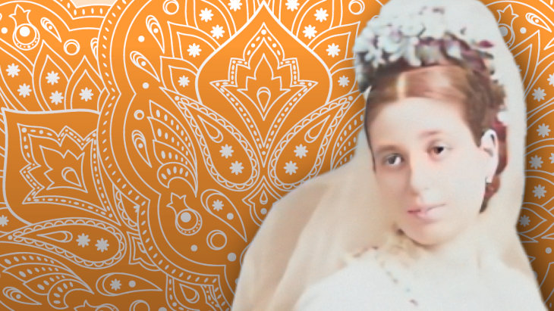

Bombay - present day Mumbai - was a bustling, growing home to many distinct Jewish communities in the year 1859, when Farha Sassoon was born there.  Bene Israel Jews, who traced their presence in India to an ancient shipwreck which deposited a Jewish community on India’s shores, began migrating to Bombay in the late 1700s, building synagogues and other civic institutions.  Other Jews from Yemen, Afghanistan, Iran and Bukhara later poured into the city, drawn by its rapidly expanding business opportunities.

Yet nobody electrified Bombay’s Jewish community as much as David Sassoon, Farha’s great grandfather.  He moved to India in 1832 to escape rising persecution from local rulers in Iraq, and founded the trading company David Sassoon & Co. in his new home.  One observer summed up the business: “Silver and gold, silks, gums and spices, opium, cotton wool and wheat - whatever moved over land and sea felt the hand and bore the mark of Sassoon and Company.”

David developed Bombay’s Sassoon Docks, and before long opened company branches throughout India, China, Hong Kong, Japan, Iraq and Britain, sending his sons to various locales to oversee their businesses there.  Some likened the Sassoon family to the Rothschilds, another Jewish family with business interests spanning many countries, bestowing the moniker “the Rothschilds of the East”.

Bottom of Form

David Sassoon built synagogues, Jewish hospitals and schools in Bombay.  Farha - her Jewish name was Frecha - was David’s great granddaughter.  Farha descended from giants of piety and business on both sides of her family. Her father, Rabbi Yechezkel Gabbai, was from another wealthy and intensely pious [Iraqi Jewish family](https://aish.com/the-jews-of-iraq/) who’d moved to India.  Like many other Bombay Jews, Farha spoke Hindi and English outside her home, and Judeo-Arabic with her relatives.

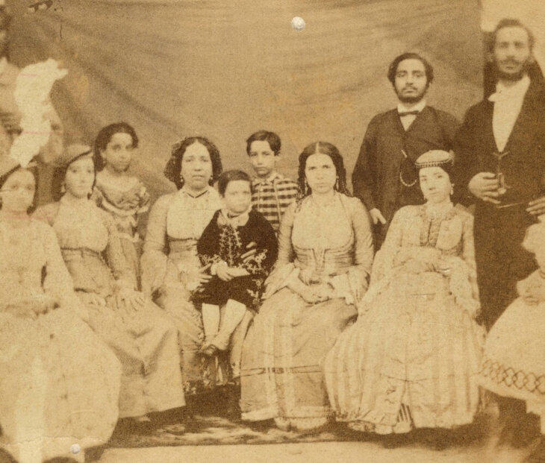

***The Sassoons***

At the time, Bombay Jews competed in business with the Parsees, Zoroastrians who fled from Persia to India in the 7th and 8th Centuries.  Jews began to copy the Parsee tradition of educating their sons but not their daughters.  For Farha’s parents, however, failing to teach their brilliant daughter was not an option.  Farha attended a Catholic school in Bombay, and her parents, hired rabbis from Baghdad to tutor her and her siblings in the evenings.  She became fluent in Hebrew, Aramaic (the language of the Talmud), Hindi, English, French and German.

She married David Solomon’s youngest son Shlomo in 1876. Twenty-eight years her senior, Shlomo was also her great-uncle.  Despite its unconventionality, the marriage seems to have been happy. Both Farha and Shlomo were intensely religious, quick-witted and hard-working, and they worked together as a team in both the realm of business and in their private philanthropic work.  They had three children together - David Solomon, Rachel and Mozelle - and moved to a magnificent house outside of Bombay in the town of Pune, where Farha and Solomon spent much of their time studying Jewish texts.

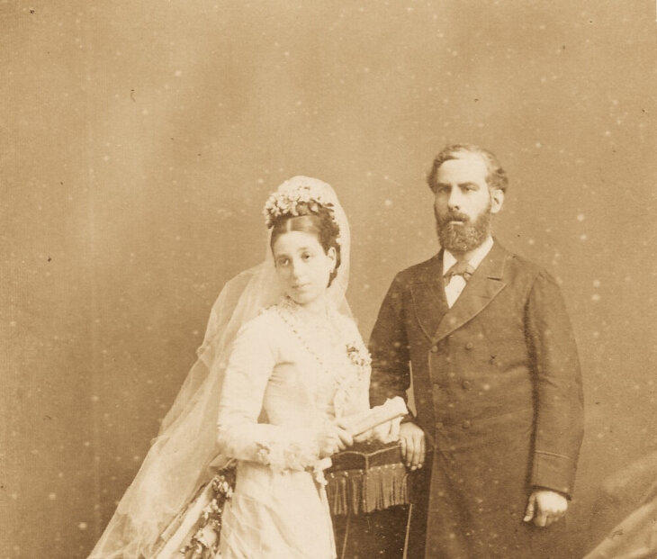

***Farha and Solomon (Shlomo)***

Friends noted that Farha adored her husband for his piety and modesty.  When he entered the synagogue he’d founded in Bombay, it’s said that Solomon would quietly slip in through a side door so as not to attract attention to himself.

Farha and Solomon were extremely wealthy and occupied the highest rungs of the British Empire’s social structure; the Prince of Wales even dined at their house in Pune.  Yet while she could entertain in the highest of style, Farha kept a strictly kosher kitchen and encouraged her guests to try the myriad different delicacies she served.  (Years later, the Prince of Wales still talked about the gifts of *amba* - a pickled mango relish which is popular in Mizrahi Jewish cooking - and dried apricots which Farha gave him.)

When Solomon traveled to Bombay for business, Farha broke all taboos on women’s roles and accompanied him to the city’s financial district in Elphinstone Circle, sitting in on business meetings and acting as an active partner in the family company.  At the time, it was a shocking assertion of independence. Despite some misgivings in Bombay’s business community, Farha eventually was accepted as a fully-fledged manager within David Solomon & Co.

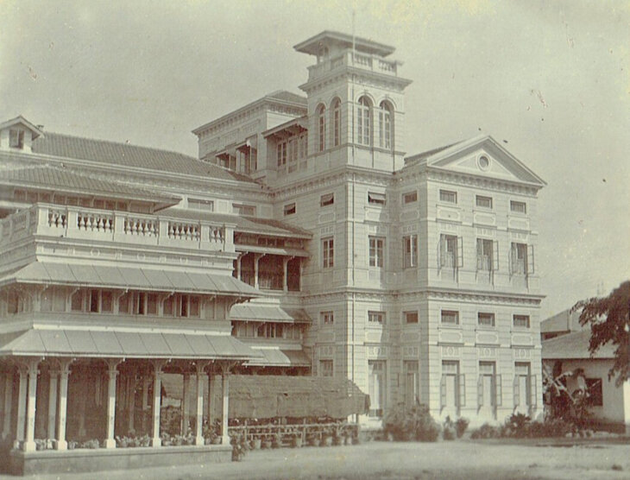

***Home of Flora and Solomon, Bombay***

Her position stood her in good stead in 1894, when Solomon suddenly passed away.  Farha declared that she was ready to take Solomon’s place.  Biographer Joseph Sassoon notes that the “Sassoon family was not prepared for a female leader.  They couldn’t look to the old country and Baghdad for a precedent, and though seemingly every day brought news of the suffragettes' activities in England, women did not run global companies there either.” (Quoted in *The Sassoons: The Great Global Merchants and the Making of an Empire* by Joseph Sassoon. Pantheon Books, New York: 2022)

After some discussion, it was agreed: Farha Sassoon would take over the running of David Sassoon and Co.’s operations in Bombay, as a full partner. With Farha at the helm, the company weathered a number of storms, including the outbreak of the First Sino-Japanese War and falling commodity prices.  Despite the difficult business environment, the Bombay office’s profits rose during Farha’s leadership.

Business was only one of Farha’s occupations.  A vigorous woman in her late 30s when she became Chairwoman of the company, Farha was a hands-on parent to her three children; letters show her arranging playdates and arranging for her son to take a boat tour of the East accompanied by servants and “a small stock of live fowls on board…to keep kosher while aboard.”

Farha’s daughter Mozelle had been dropped by a nurse when she was an infant and suffered from spinal injuries her whole life. Farha doted on her, making sure Mozelle was looked after, and also tutored her - and her other children - in Jewish studies.

**Actively Involved in Trying to**

**Improve Conditions in Her Homeland**

Farha threw herself into improving her homeland.  She campaigned against the practice of *purdah*, according to which some Indian women hid themselves away from everyone but close family members.  Farha also financially supported Waldemar Mordechai Wolff Haffkine, the Russian-born Jewish bacteriologist who set up a laboratory in the Byculla neighborhood of Bombay, where he developed vaccines against cholera and the Bubonic plague.

Throughout her life, Farha kept up a busy correspondence with many of the most eminent rabbis of the age.  In 2007, the Sassoon family published a book titled *Nahalat Avot* (Heritage of our Forefathers), comprising the many letters by great Torah sages that were sent to the Sassoon family.  A large proportion of them were sent to Farha.  Surprisingly, many of them referred to Farha as “*Rabbanit*,” a term that is used today to denote a learned woman in the Orthodox tradition, but one that was virtually unheard of in the 1800s.

**Moved to London and Entertained on**

**A Grand Scale (But Strictly Kosher)**

In 1901, shifting alliances within David Sassoon & Co. forced Farha out of her chairmanship.  Many of her relatives had moved from Bombay to London, and Farha joined them there, hoping to obtain a higher level of medical care for Mozelle there.  She adopted the anglicized name Flora, and devoted herself entirely to Torah study and to entertaining on a grand scale.

Few of the visitors to Fahra’s grand house at 32 Bruton Street in London’s grand Mayfair neighborhood realized that her legendary banquets were strictly kosher.  She held open salons once a week where the cream of London’s society would gather to speak with one another and to hear Farha’s considered opinions on the matters of the day.  The historian Cecil Roth said she “walked like a queen, talked like a sage and entertained like an Oriental potentate.”

Farha had a strict policy of responding to letters on the same day they arrived.  Jews all over the world appealed to her; many of the letters were simply addressed to “Flora Sassoon, England” - and somehow found their way to her.  She donated money to help rebuild San Francisco after the devastating earthquake there in 1906, supported Jewish schools and charities, and bankrolled Jewish hospitals and orphanages in England and across the Middle East.  With the rise of Nazism, Farha campaigned to support Jewish refugees applying to move to England.

A staunch Zionist, Farha was outspoken in her support of establishing a Jewish state in the Land of Israel.  She traveled widely, always bringing along an entourage of ten Jewish men so that she could pray with a minyan, as well as her own personal *shochet* (kosher slaughterer), ensuring that she could always access kosher food.

**Met the Great Ben Ish Chai in Baghdad**

On one trip, to Baghdad in the early 20-century, Farha met with the Chacham Yosef Chaim (1832-1909), the renowned rabbi and Jewish scholar known as the Ben Ish Chai.  While visiting his synagogue, Farha was asked to read publicly from a Torah scroll that had been donated by the Sassoon family, an honor that was highly unusual to proffer to a woman.

Yet Farha Sassoon was no ordinary woman.  At a time when female scholarship was circumscribed, she authored Jewish articles about Talmudic and Midrashic texts for *The Jewish Forum*, a scholarly publication in the United States.  An article she wrote about the Medieval Jewish commentator Rashi included a learned discussion of his work, and also highlighted the many erudite female members of his family.

Soon after her arrival in England, Farha was invited to speak at Jew’s College, London’s premier rabbinical training school.  In 1924 she was invited back to preside over Speech Day there, and gave a learned speech teeming with Talmudic references and inspiring lessons to the budding rabbis in the audience.  Her speech was later published by Oxford University Press.

When Farha died in 1936, Rabbi Yitzhak Halevi Herzog, the Chief Rabbi of the Land of Israel (and former Chief Rabbi of Ireland) noted that she had been “a living well of Torah, of piety, of wisdom, of goodness and charity, the staunchest loyalty to tradition, and out of her wonderful well Israel could draw in abundance noble incentives and lofty inspiration.”

Farha was buried on the Mount of Olives in Jerusalem, in a plot that she’d purchased on a previous trip to Israel.

*Reprinted from this week’s website of aish.com*